Experiment 25:

Aim:

To establish **IOT Based Controller with WPA and Radius Server.**

Procedure:

STEP: 1 Take server, laptop, switch.

STEP: 2 Link server to the laptop and then after link laptop to the switch.

STEP: 3 Then add the home resources like fan, light, door, gdoor.

STEP: 4 Then connect it through entering by configuration and everything it needed.

STEP: 5 Then it starts to generate the things what we have connected.

Step 1:

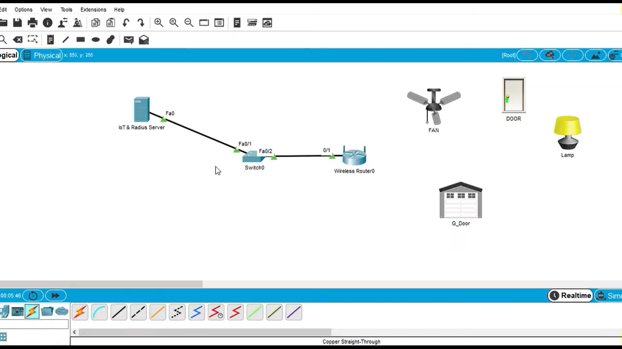

Step 2:

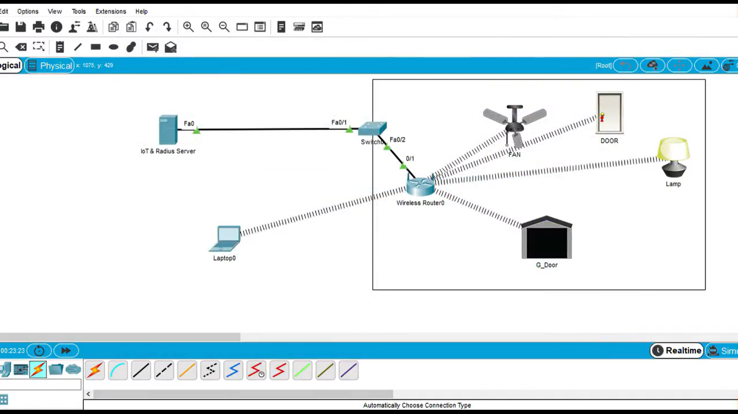

Result:

To establish **IOT Based Controller with WPA and Radius Server is verified successfully.**